**The Maria Montessori School Regatta and Duck Race**

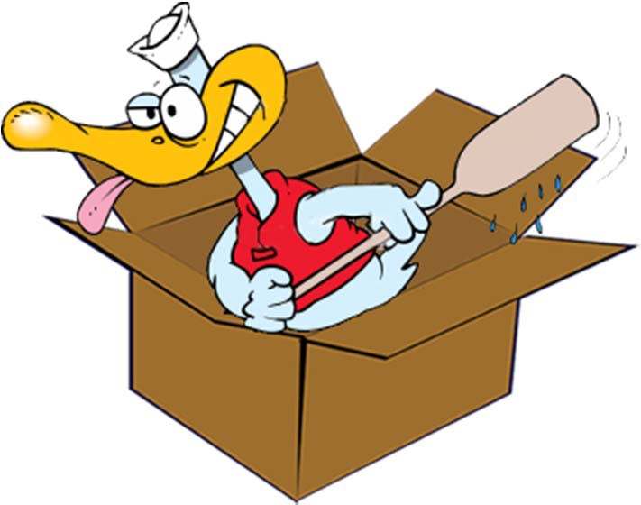

***What Floats Your Boat***

*Cardboard Boat Basics*

# Construction Materials

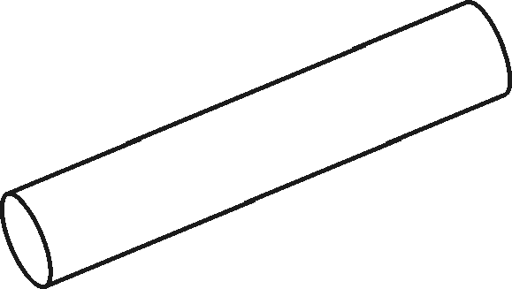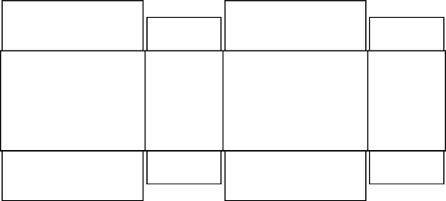

Cardboard

Block

(2-3” thick)

Carpet Tube

(about 4 ½” dia.)

Cardboard Box - cut open

# Cardboard Boat Design

* Consider its Size - building & transporting
  + Big enough to hold crew, small enough to carry
  + Wider is better, but still be able to paddle
    - no surfboard style designs are allowed
    - Rafts ARE allowed
  + Consider total weight of all materials when wet
  + EVERYTHING must be removed from the harbor
* Boat decorations & crew costumes are encouraged

- use your imagination

# Cardboard Boat ‘Physics’

* “How much will you sink? - Displacement

Water Boat Displaced Water

Displaced Volume of Water (V) V = L x W x H

Weight of Water =

62.4 pounds/cubic-foot

**Example:**

Water Displaced(ft3) = Weight-of-boat-&-people-lbs

62.4 lbs/ft3-H20 Depth(ft) boat sinks = Water Displaced(ft3)

Length X Width of boat (ft2)

Box boat, 3 ft X 6 ft, 1ft tall (high) Boat volume = 3’ X 6’ X 1’ = 18 ft3

Boat displacement = 18 ft3 X 62.4 lbs/ft3 = 1123.2 lbs Which equates to 93.6 lbs per inch of boat height

# Cardboard Boat ‘Physics’

* “Wider is Better” - Center of Buoyancy

Center-line



Center-of-gravity Center-of-buoyancy

Center-line

Center-of-gravity



Center-of-buoyancy

Righting-Arm (Moment)

POSITIVE NEGATIVE

Righting-Arm (Moment)

# Cardboard Boat ‘Physics’

* Movement Through the Water



Simple

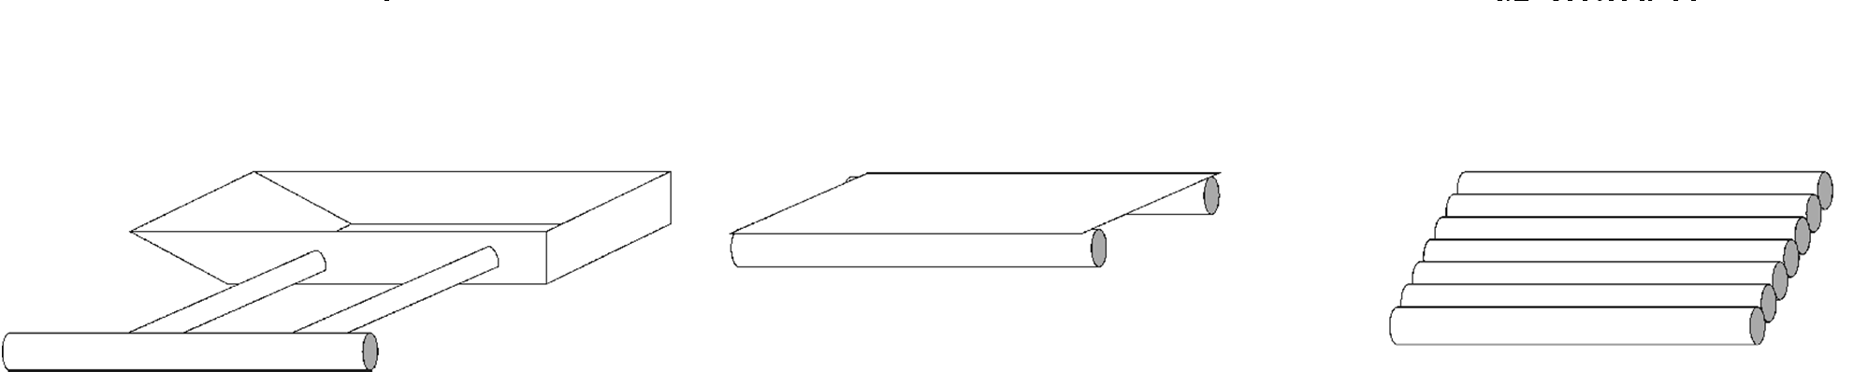

Box

Box

Bow

Outrigger

Design

Pontoon

Design

Raft

Design

9

Slanted

V-Shaped

# Cardboard Boat Design Suggestions

* Set the Design Goal: FUN, Speed or looks
* Sketch out your design
  + build a scale model from manila paper:
    - estimate materials or plan how to use what you have
    - plan out what construction techniques will be used
* 1’x1’x3’ box: will float 187 lbs.
  + if it’ll hold you, it’s big enough to float
* Flat bottoms, sit-to-paddle - are the best/easiest
* Rudders help keep you straight but make turning difficult and adds complexity to your design.

# Cardboard Boat Suggestions (cont’d)

* Long boats go fast - but are harder to turn
* Short boats (<10’) - are difficult to keep straight
* Best Length: 8-12 feet
* Best Height: 18 inches
  + allows room to sit/kneel & still paddle over the edge
* Best Width:
  + 18”-30”(max) for 1 person
  + 48” wide for 2 people side by side
* Kneeling is a “power” position but sitting is more comfortable

# Construction Tips & Techniques

* Cover edges of cardboard - acts like siphon
* Cardboard Tubes make great frames
  + Cutting for joining & bending
  + Fastening tubes together
* Cardboard Hull
  + 1-2 layers, fasten & cover the seams
  + With 2 layers, overlap the seams
  + Decorate, paint & varnish
* Reinforce the area where you sit, kneel or stand

# Construction Tips & Techniques

* Carpenter’s glue works well, liquid nails
  + hot-melt glues melts in the sun
* Duct tape only non-painted surfaces (tubes or frame that will be covered)
  + Duct tape shrinks when painted
  + Duct tape can be covered with masking tape if you need to paint it.
  + No Clear tape - it melts when painted
  + Masking tape for glued edges & seams
  + Kraft paper with spray adhesive also

# Construction Tips & Techniques

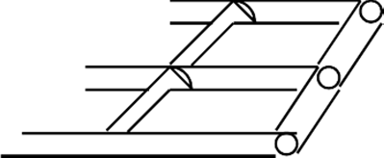**CONNECTING TUBES**



Solid Tube Frame

Center/Cross Beam Frame

**FRAMES**

Cardboard Wrapper for Tubes End-to-End

Cardboard Wrapper for Tubes At Right-Angles

# Construction Tips & Techniques

**FRAME ANGLES**

V-Shaped Cuts

Multiple Cuts for Sharper Angles

**TUBE CUTTING TEMPLATE**

# Construction Tips & Techniques

**FOLD & OVERLAP CARDBOARD AROUND CORNERS**

# Construction Tips & Techniques

**Crease/Score a line for a nice**



**STRAIGHT FOLD**

# Construction Tips & Techniques

Multiple cardboard layers “glued” together on the sides *strengthen the hull*

Multiple trapezoid-shaped pieces “glued” together to form a “*support block*”

A sheet of cardboard could be folded & “glued” together to form *tubes/beams*