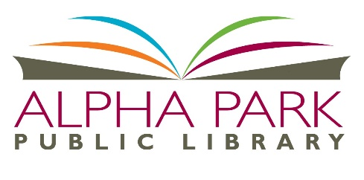
Homebound Delivery Service Application

The Alpha Park Public Library offers a free service to district residents who are unable to
visit the library due to a temporary or permanent illness or disability or those seniors who
don't have transportation. Materials made available to homebound patrons include: large and regular print books, movies, audiobooks, and magazines. Library materials are delivered free of charge.
Homebound patrons are required to hold a valid library card and must abide by borrowing policies.
To Apply for this service, simply complete the form below and return to the Outreach Librarian at the Alpha Park Public Library, 3527 S. Airport Road, Bartonville, IL 61607.

Name: ________________________________________Lib Card # _______________________
Address: __________________________________________________

City: _________________________ Phone: ___________________________

Condition preventing the applicant from visiting the library in person:
___________________________________________________________________________________________________________________________________________________________________________________________________________________________________________________

Emergency Contact: ________________________________________

Emergency Phone Number: __________________________________

Format:
_____ Regular Print _____ Large Print _____ Paperback _____ Hardback

_____ Books on CD ______ Movie DVD _____ Movie Blu-ray

____ Magazines

READING PREFERENCES:
FICTION ______ NON-FICTION ______

_____ Classics _____ Adventure _____ Travel
_____ Romance _____ Animals
_____ Mysteries _____ Arts _____ Other:
_____ Science Fiction _____ Biography _________________
_____ Western _____ Business _________________
_____ Fantasy _____ History _________________
_____ Other __________________ _____ Sports
_____________________________
_____________________________

Favorite Authors: _____________________________________________________________________________________________________________________________________________________________________________________________________________________

Delivery Notes: _____________________________________________________________________________________________________________________________________________________________________________________________________________________

For Office Use Only

Date Received: ____________________________
Date Action taken: Approved ____________ Denied ____________
Reason: ____________________________________________________________
Outreach Librarian Name: _______________________________________
Scheduled Delivery ___________________________________________________
Library Card #: ________________________

